A000-Mex-Colima-Incense Lid-Terra cotta-300 BCE-300 CE

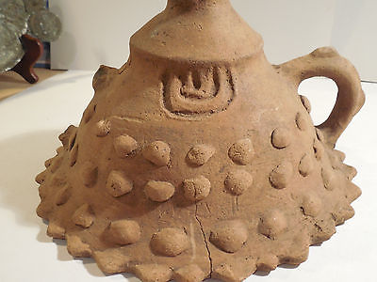 

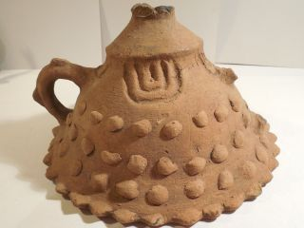

**Case No.: 9**

**Accession No.**

**Formal Label:** Mex-Colima-Incense Lid-Terra cotta-300 BCE-300 CE

**Display Description:**

Incense lids were used during ceremonies to induce the deities to inhabit the shamans who were invoking their spirits. The “U”-shaped motifs at the four cardinal points indicate the up-turned hands invoking the spirits. The knobs around the perimeter represent the clouds through which the rising incense travels to the spirits.

**LC Classification:**

**Date or Time Horizon:**

**Geographical Area:**

**Map:**

**GPS coordinates:**

**Cultural Affiliation:**

**Media:**

**Dimensions:**

**Weight:**

**Condition:**

**Provenance:**

**Discussion:**

**References:**